**"WRAVEL"**

Shreya Patel Vini Sharma

Computer Engineering & Applications Computer Engineering & Applications GLA University Mathura, India Mathura, India GLA University Mathura, India Mathura, shreya.patel_cs20@gla.ac.in vini.sharma_cs20@gla.ac.in

# 

# ABSTRACT

A travel booking website developed using the MERN stack (MongoDB, Express.js, React.js, andNode.js) offers a seamless and efficient platform for users to plan and book their travel experiences. Leveraging the power of MongoDB for database storage, the website ensures robust and scalable data management. Express.js facilitates the creation of a robust backend, handling server-side logic and providing a smooth API for communication with the front end. The use of React.js on the client side enables the development of a dynamic and interactive user interface, enhancing the user experience with features like real-time updates and responsive design. Node.js, as the runtime environment, ensures a fast and scalable server,

contributing to the overall performance of the application. Together, the MERN stack empowers the travel

booking website to offer users a reliable and feature-rich platform, from browsing destinations to making reservations, with a modern and responsive user interface.

The system will consist of two main components:

**.** The user authentication module ensures a secure and personalized experience for users, allowing them to create accounts, log in, and manage their profiles. This component employs MongoDB

for storing user data securely, while Express.js handles authentication routes and middleware to ensure secure access. React.js facilitates the creation of an intuitive and visually appealing user interface for the authentication process.

**.**

On the other hand, the booking management system is integral for users to plan and finalize their

travel arrangements. Leveraging MongoDB to store booking information, Express.js manages the server-side logic for processing and confirming reservations. React.js enables the creation of a

dynamic and responsive booking interface, allowing users to seamlessly search for destinations, view available options, and confirm their travel plans. These components work cohesively to enhance the overall functionality and user experience of the travel booking website.

# 1 INTRODUCTION

A trip booking website built with the MERN stack—MongoDB, Express, React, and Node—provides customers with an easy-to-use and effective way to organize and reserve their vacation plans. Byutilizing MongoDB's capabilities for database storage, the website guarantees scalable and reliable

data management. Express.js manages server-side logic and offers a seamless API for front-end interactions, making it easier to build a solid backend. Real-time updates and responsive design are

two aspects that improve the user experience when a dynamic and interactive user interface is developed using React.js on the client side. The runtime environment, Node.js, guarantees a quick and

scalable server, which improves the application's overall performance. When used in tandem, the MERN

stack gives the travel booking website the ability to provide users with a dependable, feature-rich

platform with a contemporary, responsive user interface for everything from exploring destinations to making reservations.

## 1.1 MOTIVATION

The motivation behind developing a travel booking website using the MERN stack lies in creating a

robust, dynamic, and user-friendly platform that streamlines the entire travel planning and bookingprocess. The MERN stack, comprising MongoDB, Express.js, React.js, and Node.js, offers a powerful and cohesive set of technologies for both the backend and frontend, ensuring efficiency and scalability. By utilizing MongoDB for data storage, the website can handle vast amounts of information, such as destination details, accommodation options, and user profiles. Express.js serves as a reliable backend framework for managing server-side logic and routing, while React.js enables the creation of a

responsive and interactive user interface, providing users with a seamless experience.

The motivation extends to addressing the needs and preferences of modern travellers who seek convenience and efficiency in making travel arrangements. The MERN stack allows for the implementation of real-time updates, intuitive navigation, and personalized user accounts through secure authentication, enhancing the overall user experience. The dynamic nature of React.js ensures that users can effortlessly browse destinations, view available options, and make reservations with ease. Additionally, Node.js contributes to the website's speed and scalability, accommodating the demands of a growing user base. Ultimately, the motivation is to offer a comprehensive and enjoyable solution for individuals looking to plan and book their travels online.

**1.2 OBJECTIVE**

**. Streamlined Booking Process:**

The website aims to simplify the travel planning process, allowing users to easily search for destinations, browse available accommodations, and book transportation and activities seamlessly.

**. Comprehensive Information:**

The website should offer comprehensive information about various destinations, including details about hotels, flights, local attractions, and activities. This helps users make informed decisions about their travel plans.

**. User Engagement:**

Engaging user interfaces and features encourages users to explore different travel options. Interactive maps, high-quality images, and detailed descriptions contribute to an immersive and enjoyable user experience. **Real-Time Updates:**

Integration of real-time updates for booking availability, pricing, and promotions ensures that users have the latest information, creating a sense of reliability and transparency.

**1.3 PROBLEM STATEMENT**

Despite the increasing demand for online travel planning and booking, there exists a significant gap in the market for a comprehensive, user-friendly, and secure travel booking platform. Existing solutions often lack a seamless integration of information, leading to fragmented user experiences. Users face challenges in navigating complex interfaces, finding reliable and up-to-date information, and encountering security concerns during financial transactions. Additionally, the absence of personalized features and real-time updates further hinders overall user satisfaction. To address these issues, there is a need for a modern, MERN stack-based travel booking website that not only streamlines the booking process but also prioritizes user engagement, information accuracy, and data security, ensuring a tailored and trustworthy platform for travelers.

1. **Inefficient User Experience:**

Many existing travel booking websites suffer from complex navigation, slow loading times, and unintuitive interfaces, leading to a frustrating user experience. Users often encounter difficulties in finding relevant information, comparing options, and completing the booking process seamlessly.

1. **Limited Personalization and Customization:**

A common issue is the lack of personalized recommendations and customization options based on user preferences. Current platforms may not effectively utilize user data to tailor travel suggestions, resulting in a one-size-fits-all approach that fails to meet individualized needs.

1. **Security Concerns:**

Online transactions involve sensitive personal and financial information, making security a paramount concern. Instances of data breaches and fraudulent activities on travel booking platforms raise concerns among users about the safety of their data, impacting trust and hindering widespread adoption.

1. **Inadequate Integration of Real-Time Information:**

Some travel booking websites struggle to provide accurate and up-to-date information on factors like pricing, availability, and promotions. Users may face discrepancies between displayed information and the actual status, leading to confusion and dissatisfaction.

1. **Poor Mobile Responsiveness:**

As mobile usage continues to rise, many travel booking websites lack effective mobile optimization. Mobile users often encounter issues such as slow loading times, distorted interfaces, and limited functionality, hindering their ability to make bookings on the go.

.

1. **WORKING**

The working of a travel booking website involves several key steps and processes, integrating the

functionalities of the MERN stack (MongoDB, Express.js, React.js, and Node.js). Below is an

**2. Browsing and Searching:**

* + Users can browse through various destinations, accommodations, flights, and activities available

on the website.

* + An intuitive and responsive user interface, powered by React.js, enables users to search forspecific destinations, view details, and filter results based on preferences.

1. **Booking Process:**

* + Users can select their desired travel options, including accommodation, flights, and activities.
  + The selected items are added to a shopping cart or a booking summary, allowing users to review

and confirm their choices before finalizing the booking.

1. **Real-time Updates:**

- Real-time updates on availability, prices, and promotions enhance the user experience, ensuring

that users have the latest information before making a booking decision.

1. **Payment Processing:**

- Secure payment gateways, integrated into the website, facilitate the financial transactions

associated with booking accommodations, flights, and activities.- SSL/TLS encryption ensures the confidentiality and integrity of sensitive user data during

payment transactions.

1. **Booking Confirmation and Notifications:**
   * Upon successful payment, users receive confirmation emails or notifications containing detailsof their bookings.
   * Users may have the option to view and manage their bookings within their user profiles.
2. **User Profiles and Personalization:**
   * User profiles store information about past bookings, preferences, and saved destinations,enhancing the overall user experience through personalization.
   * Users can manage their profiles, update information, and track their travel history.
3. **Review and Feedback:**

- Users have the opportunity to provide feedback and reviews for accommodations, flights, and activities, contributing to the community aspect of the platform and helping other travelers make informed decisions.

1. **Admin Dashboard:**

- An admin dashboard allows administrators to manage and update content, monitor bookings, and address user issues.

1. **Security Measures:**

- Security measures, such as encryption, secure authentication, and authorization mechanisms, are implemented throughout the application to safeguard user data and ensure a secure online environment.

1. **Scalability and Performance:**

- The use of Node.js for the backend ensures scalability and high performance, allowing the website to handle a growing user base and increased data volumes.

# 3. IMPLEMENTATION AND USER INTERFACE

The implementation and user interface (UI) of a travel booking website using the MERN stack involve the development and integration of various components. Below is an outline of the key aspects:

**1. Frontend (React.js):**

* **Folder Structure:**
* Organize the frontend codebase with components, containers, and utility folders for a modularstructure.

* **User Interface:**

* Design a responsive and intuitive UI with a clean layout, using CSS frameworks like Bootstrapor styled components for styling.
* Implement navigation components, such as a header, footer, and sidebar, for easy user navigation.
* Utilize React Router for handling different views and pages.

**2** **. Backend (Express.js and Node.js ):**

* **API Endpoints:**
* Define API routes and endpoints for user authentication, browsing destinations, searching, and managing bookings.
* Implement CRUD (Create, Read, Update, Delete) operations for user data, bookings, and other relevant entities.
* **Authentication:**
* Use JWT for user authentication. Implement middleware to secure routes and validate useraccess.
* **Database Integration (MongoDB with Mongoose****):**
* Connect the backend to MongoDB using Mongoose for schema-based data modeling. - Create models for users, bookings, destinations, and other relevant entities. - Middleware:
* Implement middleware functions for handling requests, error handling, and logging.

**3. User Authentication:**

* **Registration:**
* Create a registration form for users to sign up with necessary details.
* Validate user inputs and hash passwords securely using tools like Bcrypt.
* **Registration:**

* Implement a login form for users to enter credentials and authenticate.
* Generate and send JWT tokens upon successful authentication.

**4. Search and Booking Functionality:**

* **Destination Search:**
* Develop a search feature allowing users to filter and find destinations based on criteria suchas location, dates, and preferences.
* **Booking Process:**
* Design a booking workflow, including selecting accommodations, flights, and activities.- Allow users to add items to a cart and proceed to checkout for payment

**5. Payment Processing:**

* **Integration:**
* Integrate secure payment gateways such as Stripe or PayPal for handling financial transactions.- Implement SSL/TLS for encrypting sensitive data during payment.

**6. User Profiles and Personalization:**

* **Profile Management:**
* Provide users with a dashboard to manage their profiles, view booking history, and updatepersonal information.
* Enable users to save preferences and favorite destinations.

1. **Real-time Updates:** 
   * WebSocket Integration (Optional):
   * Implement real-time updates for availability, pricing, and promotions using WebSocket technology.
   * Notify users instantly about changes or new offers.
2. **Feedback and Reviews:**

* **User Ratings:**
* Allow users to leave ratings and reviews for accommodations, flights, and activities.
* Display aggregated ratings on the platform.

**9. Admin Dashboard:**

* **Access Control:**
* Create an admin dashboard with access controls for managing content, monitoring bookings,and addressing user issues.

**10. Testing:**

* **Unit Testing:**
* Implement unit tests for critical components to ensure functionality.
* **User Testing:**
* Conduct user testing to gather feedback on the user experience and make improvements.

**11. Deployment:**

* **Server Deployment:**
* Deploy the backend on a server using platforms like Heroku, AWS, or Digital Ocean.
* **Frontend Deployment:**
* Deploy the frontend to a static hosting service like Netlify or Vercel.

**.**By focusing on these aspects during the implementation, you can create a travel booking website with a user-friendly interface that effectively meets the needs of travelers while leveraging the strengths of the MERN stack

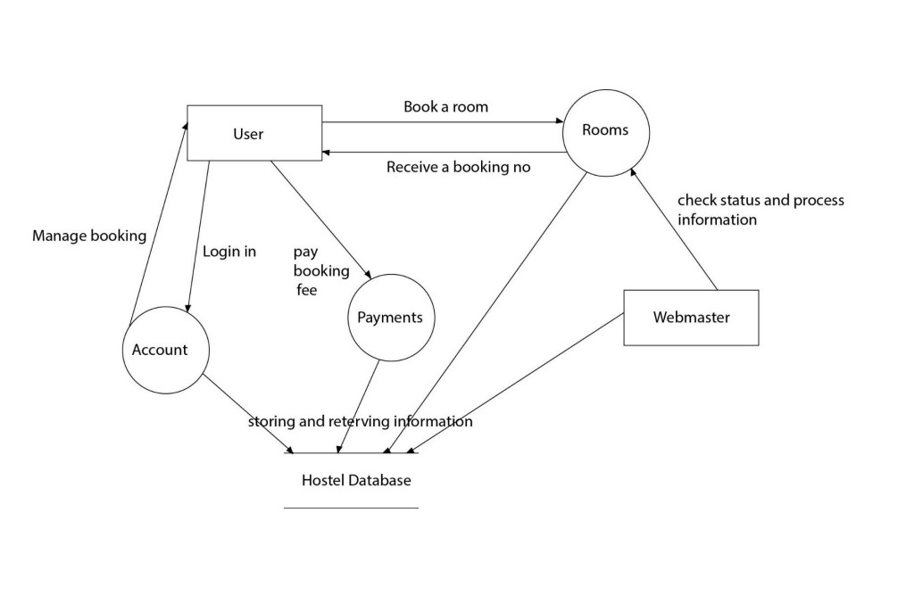

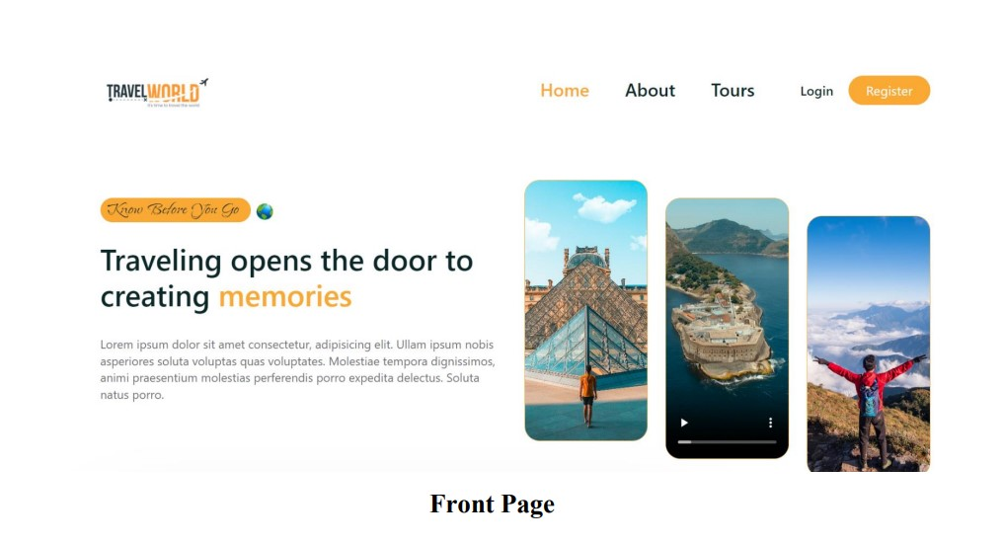

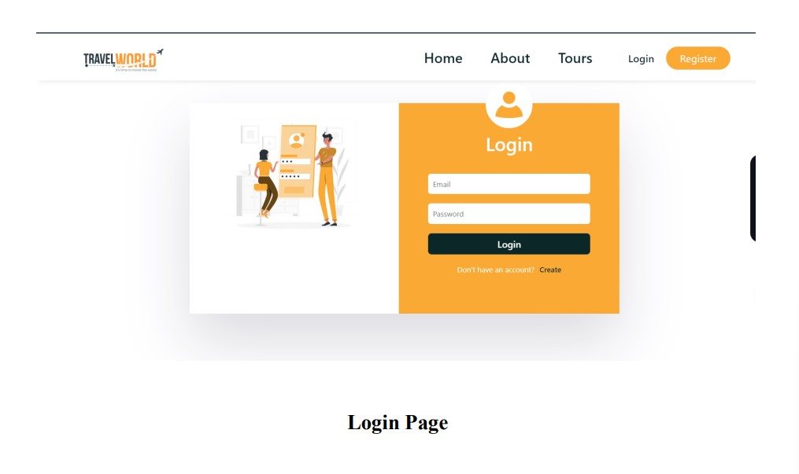

# 4. CONCLUSION

In summary, modern travelers looking for seamless booking and planning experiences can find a comprehensive and effective answer in a travel website built with the MERN stack. A strong foundation is provided by the combination of Express.js, React.js, MongoDB, and Node.js, enabling a dynamic and responsive platform. The website's user interface puts an emphasis on responsiveness, clarity, and intuitiveness while providing users with an eye-catching and captivating experience.

The MERN stack's scalability and performance advantages, which enable the website to accept an expanding user base and manage higher data volumes, further underscore the project's success. User support and effective content management are made possible via the admin dashboard.

Essentially, the trip booking service encourages a sense of community through user evaluations and feedback in addition to streamlining the travel planning process. The MERN stack offers a versatile and adaptive framework that keeps up with technological advancements, establishing the trip booking website as a cutting-edge option in the rapidly changing field of online travel platforms. With constant enhancements, user testing, and adjustments to industry developments, the trip booking website is still in a position to provide a smooth and delightful travel experience for customers all over the world.

# 5. FUTURE SCOPE

A travel booking website's future potential is bright and dynamic, with chances for ongoing innovation and technological adaption. By offering recommendations that are specifically catered to the interests and actions of the user, the combination of machine learning (ML) and artificial intelligence (AI) hasthe potential to improve customization. Technologies like virtual reality (VR) and augmented reality (AR) could completely change the way people travel by providing immersive glimpses of places to visit and places to stay. Blockchain technology may be investigated to improve transaction security

and safeguard user information. Adding intelligent capabilities like voice-activated search and chatbots for real-time customer support to the platform might also increase its competitiveness in the rapidly changing online travel services market. Staying up to date with technical developments and consumer

preferences will be essential to maintaining the trip booking website's leadership position in the market.

# 5. REFERENCES

1. https://stackoverflow.com/
2. https://chat.openai.com
3. https://developer.mozilla.org/en-US/